Video-Based Abnormal Driving Behaviour Detection via Deep Learning Fusions

In this paper author is describing concept to detect abnormal driving behaviour from videos using Deep Learning Algorithms such as Wide Group Densely (WGD) Network, Wide Group Residual Densely (WGRD) Network and Alternative Wide Group Residual Densely (AWGRD) Network. All algorithms build training models to detect abnormal behaviour but AWGRD works better than other two algorithms so I implemented AWGRD Algorithm.

Existing CNN Algorithm works better by monitoring eyes, mouth, monitor heart by using sensor and monitoring hands behaviour by using sensors but this algorithms give false prediction. For example while eyes monitoring if user turn around then algorithm will not detect eyes and consider driver is sleeping and sometime driver go to sleep without closing eyes, Using sensors for monitoring will put extra burden on driver.

To overcome from above issues author has describe 3 algorithms based on CNN deep learning models.

1. Wide Group Densely (WGD) Network: Technically, WGD takes important issues of deep learning models, i.e., the depth, the width and the cardinality, into consideration when designing its model structure based on Dense Net. This model use deep features from input train model to get better prediction accuracy.
2. Wide Group Residual Densely (WGRD) Network: The most significant change of WGRD with respect to WGD is that, the idea of residual networks is incorporated in WGRD. In this algorithm input image will pass from one layer to other residual layer to have best features from train input image to get best accuracy.
3. Alternative Wide Group Residual Densely (AWGRD) Network: This algorithm works similar to above two algorithms but while passing input data from one layer to other, this algorithm will take super positions of previous layers which has best features from all layer and will have better prediction accuracy. Due to super positions extraction training efficiency will undoubtedly become higher.

Module Information

1. Generate & Load AWGRD Model: Using this module AWGRD train model will be generated from input images download from Kaggle state farm distracted driver detection database. This database contains 22424 images and model is built by using all those images.
2. Upload Video: using this module we can upload video to this application and then start playing video using Python OPENCV library.
3. Start Behaviour Monitoring: Using this module we will extract each frame from video and then resize image according to AWGRD Model. AWGRD Model will be applied on this frame to predict behaviour of driving person. All behaviours will be displayed on playing video.

Screen shots

To run this project double click on ‘run.bat’ file to get below screen

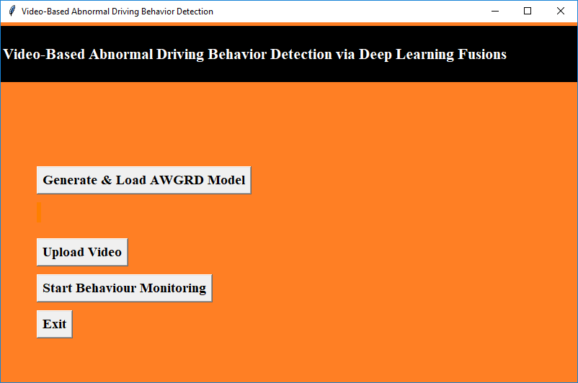

In above screen click on ‘Generate & Load AWGRD Model’ button to generate AWGRD train model. All model information we can see in black console after clicking on button

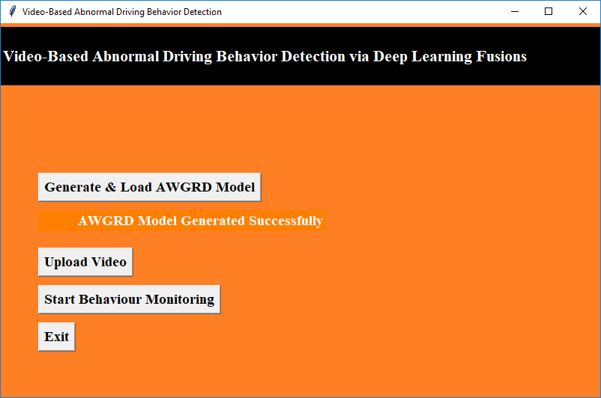

In above screen we can see model is generated and in below screen we can see all details

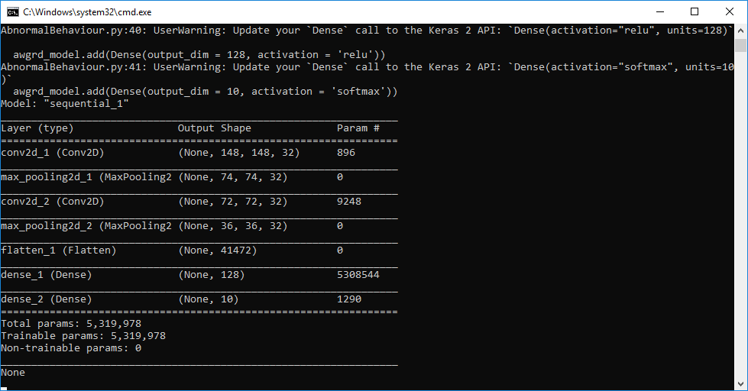

In above screen dense model using AWGRD is created. Now click on ‘Upload Video’ button to upload video

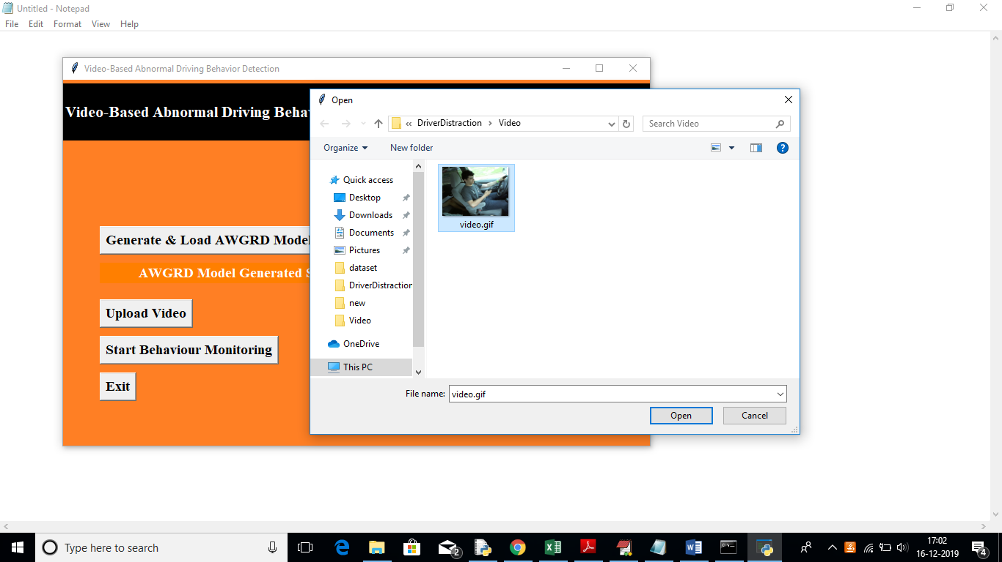

In above screen uploading one video and then click on open button and then click on ‘Start Behaviour Monitoring’ button

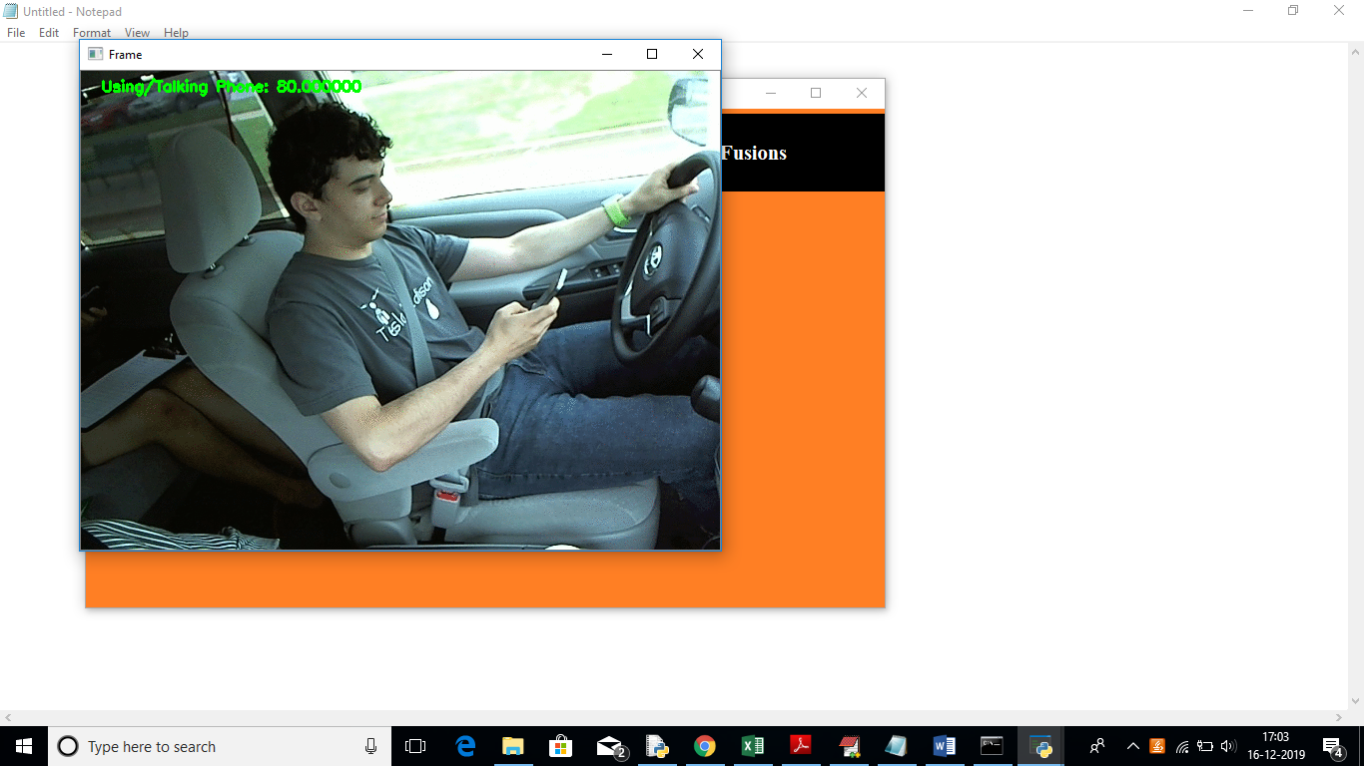

In above screen application detected user is using/talking on phone

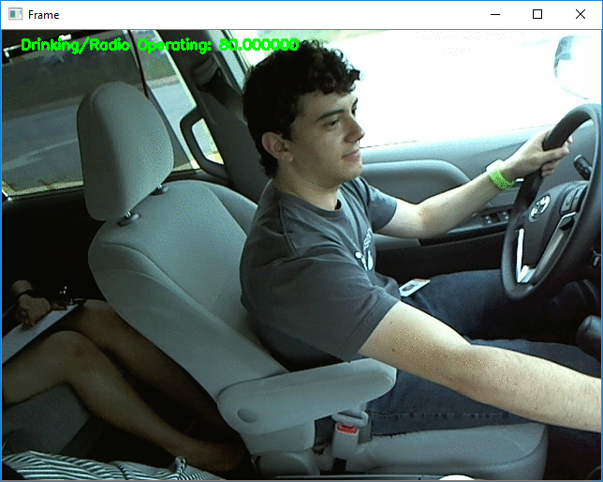

In above screen we can see user is try to start Radio. Similarly other detection will also be performed.

Here I train this model on small laptop and detecting accuracy will not be 100% as we need to train model using lakhs of images and this training has to be done on high configuration machines. In this normal laptop to build model on 20000 images it took 2 hours of times. So I used few images for training and it will work up to 80% correct prediction. To have 100% accuracy we need to have large computers like google.